**I Will Give You The Keys To The Kingdom Of Heaven**



**Matthew 16:19**

***Revelation from the Lord God to the angel of the church of Philadelphia, Jonathan Kleck.***

**TABLE OF CONTENTS 1**

**Synopsis** **1**

John 15:13 King James Version *(KJV)*

**Excerpt** **2**

Genesis 6:1-8 New King James Version *(NKJV)*

**Introduction 3**

Colossians 1:26 New American Standard Bible *(NASB)*

Daniel 12:4 *(KJV)*

Matthew 16:19 King James Version 2000 *(KJV2000)*

**The Prince Of The Power Of The Air, Those Who Hide Their Plans From The Lord 4**

Isaiah 29:15

Ephesians 2:2

2 Corinthians 4:3-4

Psalms 82:6-8 *(KJV)* **5**

John 10:34-38 *(KJV)*, *(spoken words by Jesus in red)*

Gen 1:26-27 *(KJV)*  **6**

**Knowledge Of The Qliphoth**  **7**

Luke 4:4-8 King James Bible 2000 *(KJB2000)*

Romans 8:36 *(KJV)*

**Qliphoth** **8**

**The Transmutation Process** **9**

**The Isotoxal Star** **10**

**Hendecagram And Goddess Of Liberty** **11**

**Mother Of Exiles** **12**

**The Light Bearer** **13**

**Spark Of Life** **14**

**Mitochondria The Powerhouse** **15**

*Heart Mitochondria: Gates Of Life And Death* **17**

*Heart Mitochondria: Gates Of Life And Death* **18**

**The Woman Arrayed In Purple And Scarlet 19**

Revelation 17:1-5 New King James Version *(NKJV)*

**Male And Female Chromosomes** **22**

Luke 1:35 *(KJV)*

Matthew 1:18 *(KJV)*

Matthew 1:23 *(KJV)*

Isaiah 7:14 *(KJV)*

**Female Energy 23**

Isaiah 30:1 *(KJV)*

Daniel 2:43-44 *(KJV)* - Iron mixed with Clay **24**

Genesis 2:7 *(KJV)*

**Our Kingdom Divided 25**

1 Corinthians 3:16 *(KJV)*

Genesis 6:2 *(KJV)*

Genesis 3:15 *(KJV)*

John 10:1-5 *(KJV)* **26**

Matthew 12:25 *(KJV)*

**Condition of our Kingdom Divided 26**

**Duality 26**

**The Antichrist Barack Obama 27**

**The Meaning Of 666 And The Antichrist 28**

Revelations 13:18 *(KJV)*

[**DNA, Genes and Chromosomes — University of Leicester**](https://www.google.com/url?sa=t&rct=j&q=&esrc=s&source=web&cd=1&cad=rja&uact=8&ved=0ahUKEwjRz87CrP_bAhWB_p8KHWIDANEQFggsMAA&url=https%3A%2F%2Fwww2.le.ac.uk%2Fprojects%2Fvgec%2Fhighereducation%2Ftopics%2Fdna-genes-chromosomes&usg=AOvVaw1B_87IeR9r6mBGTJ9ANFZg) **29**

Luke 10:18 *(KJV)*

**2 Creation Accounts,  30**

Genesis 1, Genesis 2

Isaiah 14:12-18 New King James Version *(NKJV)*

**TABLE OF CONTENTS 2**

**Messengers Of Flaming Fire 31**

Hebrews 1:7 *(KJV)*

**Converting Angels To Locusts 32**

Revelation 9:7-10 *(KJV)* **33**

List Of Popes – Vatican **34**

Matthew 7:14 (*KJV*), (*spoken words by Jesus in Red*)

The World Population History **35**

Isaiah 52:5 *(KJV)* **36**

Isaiah 57:4 *(KJV)*

Psalms 35:19 *(KJV)*

The Vatican Is The Altar Of Saint Peter That Is A Giant Dead Sheep.

**“IN A NUTSHELL”** **37**

**Conclusion** **38**

Ephesians 5:11-14 (*KJV*)

**Eyes to See and Ears to Hear Scripture 39**

Matthew 13:10-15 (*KJV*), (*spoken words by Jesus in Red*)

Revelations 2:28 *(KJV)*

Jeremiah 29:11 *(KJV)*

Hebrews 12:29 *(KJV)*

**We Are A Holy Temple For God To Occupy. 40**

1 Peter 2: 4-10 King James 2000 *(KJB2000)*

**Awaken Scripture 41**

Ephesians 5:6-14 King James 2000 *(KJB2000)*

[Isaiah 40:31](https://www.biblegateway.com/passage/?version=KJV&search=Isaiah%2040:31) *(*[*KJV*](https://www.biblegateway.com/versions/index.php?action=getVersionInfo&vid=9)*)*

Isaiah 43:1 *(KJV)*

**References 42**

**BACK COVER**

Image from the movie, Day Of Reckoning, Locusts coming out of the Pit.

Revelation 9

**Synopsis**

The biggest trick Satan ever pulled is keeping people *(us angels)* in the dark and having us believe he doesn’t even exist. This is the greatest identity crises ever. We are angels and don’t even know it.

Satan and the rebel angels created these human host bodies to trap us *(our light essence)* on earth. The human host body is an illusion, an Idol, a lie, as is the host body / system, the whole earth that Satan helped create.

In not so many words, the truth is that we are from the Lord God, eternal angels; **messengers of flaming fire with bodies of LIGHT**. We fell from heaven into these human host bodies of flesh through birthing and our DNA is our chains of darkness. Satan and the rebel angels are not us. They are the Angels that fell first from the rebellion Satan started in heaven. They fell into a Pre-Adamic earth and populated it and the rest of us angels fell after them and continued breeding more angels into the flesh for them below.

As the architect, the Lord God allows his angels to use His commands or codes to create. Satan stole the Lord Gods codes of life and used them to create abominable things in this world, even the Pre-Adamic man and beast of various kinds. In that time, after the rebellion in heaven, Satan and the rebel angels were cast out of heaven and down to earth. This is when Satan inherited the earth as his own kingdom, just as he wanted.

Satan and the rebel angels fell into EVERLASTING chains of darkness and will not be coming back to heaven. The rest of us angels fell into chains of darkness of the flesh *(DNA)* but they are not everlasting and we can come back home. But we have to be converted *(receive a new spirit, the Holy Spirit)* in order to come back.

You can say that Satan is on an appeal since he was cast out of heaven and his final judgment hasn’t taken place yet. He is the God of this world. That he not only owns but also controls our flesh bodies, known as the qliphoth. He has been ruthlessly ruling over this world, the system and us angels while keeping us in the dark.

This is a custody battle for the Lord God’s children, everyone in this world, His angels trapped in the serpent flesh. This is why our father came into the earth which is the **Matrix** *(****Womb****)* system of the flesh. He came into the earth to take us back from Satan who stole us away. Our father, the Lord God won back custody of his children when he took the cross for us. Now it’s time for Him to take us back home. As for Satan and his appeal, the court case is over, he lost the trial and now his judgment follows.

**John 15:13** King James Version *(KJV)*

**13 Greater love hath no man than this, that a man lay down his life for his friends**.

Angels, Gods children falling from Grace, Heaven.

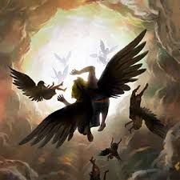

**Excerpt**

So that the next information provided is more digestible, let us dive deeper into Satan’s works, even closer to the beginning of the earth’s age. I believe that there are two world ages and the second world age is now at its end. We are entering the third world age which is in the final phase of the New World Order *(NWO).*

Explaining further, without getting into timelines, the 1st world age was Pre-Adamic earth, meaning before Adam fell to earth. At that time Satan and the rebel angels started the rebellion in heaven and they were cast down to the earth that they helped create. Satan and the rebel angels broke off from the Lords will and they created Pre-Adamic man and enslaved them, making them the builders on earth.

Satan wanted his own kingdom on even the earth he helped to create. He began the insurrection in the heavens through convincing falsities unto the angels. With lies he tried to convince us angels to follow him. With deceitful promises that If we followed him, we would be as gods, having eternal life which we already had, our own kingdom to rule over with our own families and licentious *(illegitimate, sinful)* freedom. ***(See Genesis 3:1-6)***

The 2nd world age *(7 thousand years long)* that followed was when the rest of us angels started falling from grace to earth. This was at the time of Adam and Eve. They represent all of our class of angels and they were the first of us to fall to earth through Satan’s influence. The earth was already inhabited by Satan and the rebel angels and their creations.

Adam and Eve fell, when Eve was tempted by Satan in the garden. Satan seduced Eve into having sex with him and then Eve seduced Adam as well. Eve birthed Cain and Abel who were twins from different fathers, which is known as **superfecundation**. Cain’s father was Satan and Abel’s father was Adam. Cain was the first born and first debased *(corrupted)* man that was created on earth. Since Satan was his father, Cain was a fallen angel and a Nephilim. Cain was also Satan’s first human host body and from then on, Satan would have full legal rights to every human host body, the qliphoth and the whole world system. ***(See Genesis 3 and 4)***

Afterwards 200 angels called the watchmen, who came to earth on Mt. Herman, and made a pack with him, taking wives of whomever they chose, to have sex with. Cain, the fallen angels, and the watchman created more abominations like the Nephilim giants that roamed the earth in those days along with the many abominable beasts. At the time of Noah, things became so horrific that the Lord God flooded the earth to wipe out these abominations. ***(See Genesis 6:1-8)***

**Genesis 6:1-8** New King James Version*(NKJV)*

*The Wickedness and Judgment of Man*

**1** Now it came to pass, when men began to multiply on the face of the earth, and daughters were born to them, **2** that the sons of God saw the daughters of men, that they *were* beautiful; and they took wives for themselves

of all whom they chose.

**3**And the Lord said, “My Spirit shall not strive with man forever, for he *is* indeed **flesh**; yet his days shall be one hundred and twenty years.” **4** There were giants on the earth in those days, and also afterward, when the sons of God came in to the daughters of men and they bore children to them. Those *were* the mighty men who were of old, men of renown.

**5**Then the Lord saw that the wickedness of man *was* great in the earth, and *that* every intent of the thoughts of his heart *was* only evil continually. **6** And the Lord was sorry that He had made man on the earth, and He was grieved in His heart. **7** So the **Lord said, “I will destroy man whom I have created from the face of the earth, both man and beast, creeping thing and birds of the air, for I am sorry that I have made them**.” **8 But Noah found grace in the eyes of the Lord**.

**Introduction**

The information provided in this document has been given by the Lord God to his prophet, ***Jonathan Kleck***,

who has been chosen *(predestined)* to ring the bell and gather the church of Philadelphia.

This is my humble attempt in conveying the intended meaning of this information in written form. I mean only to shine a light in the darkness and to offer anyone who would listen, the hidden knowledge of the truth, given by the Lord God.

I would also like to take a moment to give a disclaimer; that all the information in this document is revelation given to the Lord God’s church, His saints and that all of it is true and consistent with scripture in the bible.

In this journey, this information will focus on **who we are**, **where we are from and what our purpose is.**

I understand that the perception of attempting to encapsulate a large subject matter concisely into an easily-digestible document can be perceived as naive, and although the undertaking of this task is challenging; I am hopeful that the information given to you here becomes clear to you.

To conserve time, it behooves me to keep things as simple as possible while still remaining faithful to the truth. This is why the information provided was designed to be to the point, without getting into too much detail, yet still leaving room for discussion.

This information in part, is the hidden knowledge of the truth revealed in the end days ***(Colossians 1:26)*,** the unrolled scroll ***(Daniel 12:4)*** and the keys to the kingdom of heaven ***(Matthew 16:19)***.

**Colossians 1:26** New American Standard Bible *(NASB)*

**26** *that is,* the mystery which has been hidden from the *past* ages and generations, but has now been manifested to His saints.

**Daniel 12:4** *(KJV)*

**4** But thou, O Daniel, shut up the words, and seal the book, *even* to the time of the end: many shall run to and fro, and knowledge shall be increased.

**Matthew 16:19** King James Version 2000*(KJV2000)*

**19** And I will give unto you the **keys of the kingdom of heaven**: and whatsoever you shall bind on earth shall be what has been bound in heaven: and whatsoever you shall loose on earth shall be what has been loosed in heaven.

**The Prince Of The Power Of The Air, Those Who Hide Their Plans From The Lord**

In the bible, **Isaiah 29**; has been the key used for the discernment and disclosure of many revelations the lord has so graciously given us.

**Isaiah 29:15** *(KJV)*

**15** Woe unto them that seek deep to hide their counsel from the LORD, and their works are in the dark, and they say, Who seeth us? and who knoweth us?

**16** Surely your turning of things upside down shall be esteemed as the potter's clay: for shall the work say of him that made it, He made me not? or shall the thing framed say of him that framed it, He had no understanding?

What do you do when you put a key in a lock? You turn the key upside down and the door opens. The truth is revealed and then you are set free.

Satan always hides his plans from the masses in plain sight, upside down. For us to be able to see them, all we need do is literally turn things upside down.

*Below is an image of a dead sheep that Satan hid in an image of the virgin. The following image shows life right side up and death upside down*.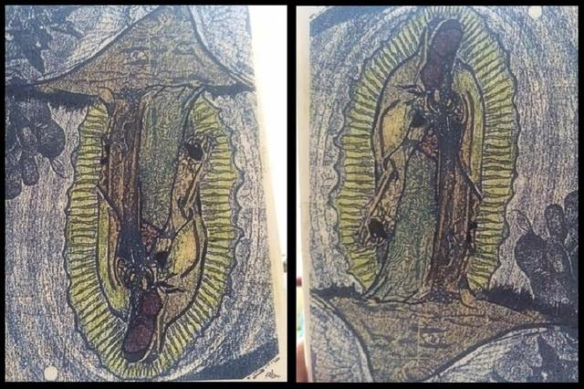 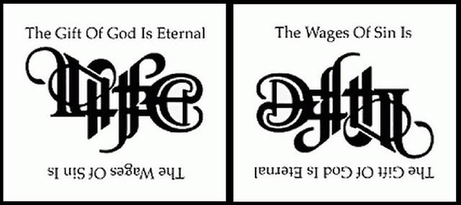

*Excerpt from article:*

“Before being called, Christians have walked according to the course of this world. The fact that Satan is the prince of the power of the air reveals more than meets the eye. Radio, television and other modes of communication are broadcast through the air. Similarly, Satan influences humanity by broadcasting attitudes into their minds. He can control people’s moods, influencing their outlook or general behaviour. Since our minds are naturally tuned to his wavelength, only by awareness of this manipulation can we resist the influence.”

**Ephesians 2:2**

**2** Wherein in time past ye walked according to the course of this world, according to the **prince of the power of the air**, **the spirit that now worketh in the children of disobedience**:

**2 Corinthians 4:3-4**

**3** But if our gospel be hid, it is hid to them that are lost:

**4** In whom the god of this world hath **blinded the minds of them which believe not**, lest the light of the glorious gospel of Christ, who is the image of God, should shine unto them.

The children of disobedience walk in accordance with the prince of the power of the air and he has blinded their minds and their hearts.

As you continue to read through this information, It will become evident that the knowledge that we are all actually angels has been hidden from the world. It will become clearer in **Psalm 82** and **John 10** that we are all angels.

To reveal the truth, let’s do a little bible study and during the process, let’s consistently match the Hebrew and Greek word /s originally used in the bible with their true meanings. Then read the scripture again, but this time replacing the word /s in the scripture with the definition of the word /s that were matched.

I have highlighted the words and listed their corresponding numbers for you. **H** is for **Hebrews** and **G** for **Greek**.

**________________________________________**

If the Lord God is our Father and the almighty King and we are His children. Then by definition, that makes us His angels, royal princes and heirs to His kingdom. Below are the scriptures that support that we are angels.

**Psalms 82:6-8** *(KJV)*

**6** I have said, Ye *are* gods**H430**; and **all** **of you** are children of the most High.

**7** But ye shall die like **men**, and fall like one of the **princes**.

**8  Arise**, O God**H430**, judge the earth: for thou shalt inherit all nations.

*Bible definitions of Strong’s Hebrews words gods****H430*** *and O God****H430***

*אֱלֹהִים*, *ĕlôhı̂ym*, el-o-heem'***H430***

gods *in the ordinary sense; but specifically used (in the plural thus, especially with the article)* ***of the*** *supreme* God*; occasionally applied by way of deference to* magistrates*; and sometimes as a superlative: - angels, X exceeding, God (gods) (-dess, -ly), X (very) great, judges, X mighty.*

**Total KJV occurrences: 2601**

**________________________________________**

**John 10:34-38** *(KJV)*,(*spoken words by Jesus in red*)

**34**Jesus answered them, Is it not written in your law, I said, Ye are gods**G2316**?

**35** If he called them gods, unto whom the word of God came, and the scripture cannot be broken;

**36** Say ye of him, whom the Father hath sanctified, and sent into the world, Thou blasphemest; because I said, I am the Son of God?

**37** If I do not the works of my Father, believe me not.

**38** But if I do, though ye believe not me, believe the works: that ye may know, and believe, that the Father *is* in me, and I in him.

*Bible definitions of Strong’s Greek word gods****G2316***

*Theos, theh'-os****G2316***

*Of uncertain affinity; a deity, especially (with G3588) the supreme Divinity; figuratively a magistrate; by Hebraism very: - X exceeding, God, god [-ly, -ward].*

**Total KJV occurrences: 1343**

Simply said, we are royal princes, angels that fell from heaven. When we fell, we were birthed into the Matrix**H7358**. The Matrix**H7358** is a carnal state, in the realm of the flesh. Our fall is being birthed into a flesh host body of the serpent skin and as it says in the word of God, definitively, “but you shall **die like men**”.

*Bible definitions of Strong’s Hebrews word Matrix****H7358***

*רֶחֶם,Rechem, rekh'-em****H7358***

*From H7355;* ***the womb*** *(compare H7356): -* ***matrix****,* ***womb****.*

**Total KJV occurrences: 26**

Satan and the rebel angels created this human host body, the qliphoth *(which will be delineated later)* which houses our angelic essence and they created the world system to control us like cattle. You must understand that Satan and the rebel angels created the qliphoth our human host body in their image, meaning in the serpent flesh and from the beginning, they commanded us to breed and multiply for them.

**Gen 1:26-27** *(KJV)*

**26** And God**H430** said, Let us make man in our image**H6754**, after our likeness: and let them have dominion over the fish of the sea, and over the fowl of the air, and over the cattle, and over all the earth, and over every creeping thing that creepeth upon the earth.

**27** So God**H430** created man in his own image**H6754**, in the image**H6754** of God**H430** created he him; male and female created he them.

*Bible definitions of Strong’s Hebrew words God****H430***

*אֱלֹהִים, ĕlôhı̂ym,* *el-o-heem'****H430***

*Plural of H433;* gods *in the ordinary sense; but specifically used (in the plural thus, especially with the article)*

***of the supreme* God*;*** *occasionally applied by way of deference to* magistrates*; and sometimes as a superlative:*

*-* ***angels****, X exceeding, God (gods) (-dess, -ly), X (very) great, judges, X mighty.*

**Total KJV occurrences: 2601**

*Bible definitions of Strong’s Hebrews words image****H6754***

*Tselem,* *tseh'-lem****H6754***

*From an unused root meaning to* shade*;* ***a* phantom***, that is, (figuratively)* **illusion***,* resemblance*; hence a representative* figure*, especially an***idol**: - *image,* ***vain shew****.*

**Total KJV occurrences: 17**

*Below is an image of the human flesh under a micro scope that matches serpent scales.*

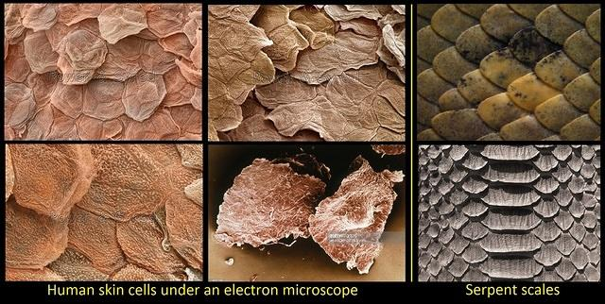

**Knowledge Of The Qliphoth**

The following information is a closer look at the human host body known as the qliphoth.

In the Kabbalah Judaism esoteric teachings, the qliphoth represents our human host bodyand is also known as an 11 pointed star called a Hendecagram. Also within the qliphoth is a 3 pointed star called an Isotoxal.

The qliphoth is unholy and it acts as a *peel, shell or Husk* and the *isotoxal is the same as the transmutation circle* used to change our energy without changing its shape or form. For a visual understanding, refer to the images on following pages.

The qliphoth *(human host body)* is inherently evil and constantly attracts sin. It houses holiness *(our angelic energy)* and the isotoxal star converts it to evil through constantly sinning. Constantly sinning over time turns our angelic light into dark energy that cannot and will not return to heaven in that state. Anyone who has not been converted when their human host body *shell* dies, the angelic energy, will go down to the pit.

So, what’s the point to all of this?

Satan, the God of this world, inherited earth upon his fall and although it belongs to him, the Lord God is ultimately in control. Satan and his angels control the world population and the world system. Below are the scriptures that prove this world belongs to Satan.

**Luke 4:4-8** *King James Bible 2000**(KJB2000)*

**4** And Jesus answered him, saying, It is written, Man shall not live by bread alone, but by every word of God.

**5** And the devil, taking him up into a high mountain, showed unto him all the kingdoms of the world in a moment of time.

**6 And the devil said unto him, All this power will I give you, and the glory of them: for that is delivered unto me; and to whomsoever I will I give it.**

**7** If you therefore will worship me, all shall be yours.

**8** And Jesus answered and said unto him, Get you behind me, Satan: for it is written, You shall worship the Lord your God, and him only shall you serve.

**Romans 8:36** *(KJV)*

**36** As it is written, For thy sake we are killed all the day long; we are accounted as sheep for the slaughter.

**Qliphoth**

Let us begin with some foundational information, so that later on you could better comprehend what is been presented.

In the Kabbalah Judaism esoteric teachings, the qliphoth represents our host body, the flesh that we *(angels)* are trapped in. It is inherently evil and acts as a shell, peel or husk, trapping our holiness *(eternal angelic light)* within it. It’s also known as the **Lucifer Star** Polygon.

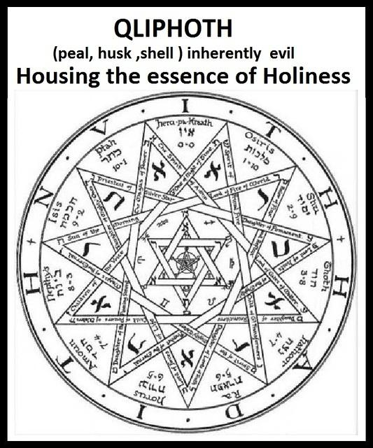

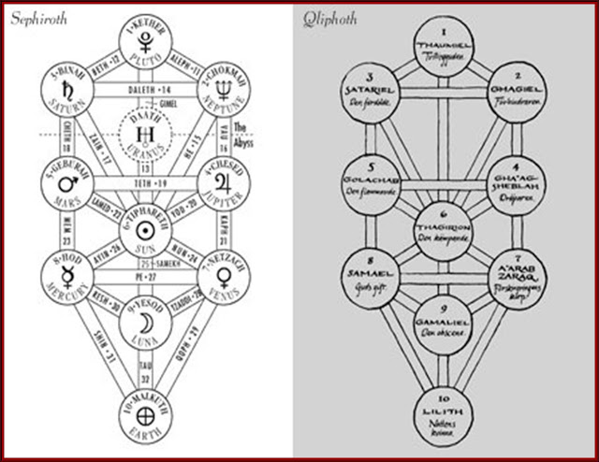

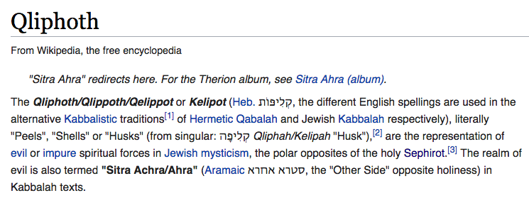

**The Transmutation Process**

The metaphysical science and mystical art of manipulating and altering matter is represented by the picture below in the transmutation circle. The highlighted area beneath is the process in each step required to accomplish transmutation.

In alchemy the human transmutation circle within our host body *(shell)*, converts our angelic energy to dark energy through constant sin.

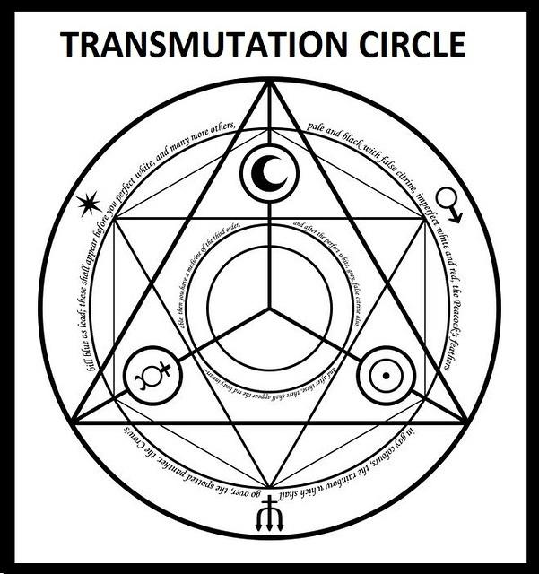

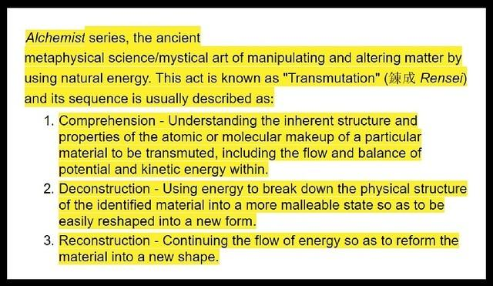

**The Isotoxal Star**

Within the Isotoxal star is where the transmutation process takes place within the human host body.

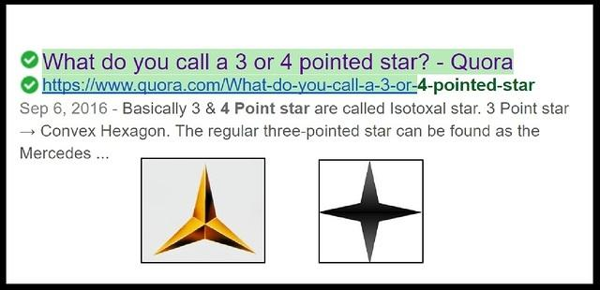

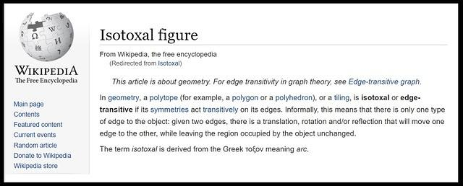

In [geometry](https://en.wikipedia.org/wiki/Geometry), a [polytope](https://en.wikipedia.org/wiki/Polytope) (for example, a [polygon](https://en.wikipedia.org/wiki/Polygon) or a [polyhedron](https://en.wikipedia.org/wiki/Polyhedron)), or a [tiling](https://en.wikipedia.org/wiki/Tessellation), is **isotoxal** or **edge-transitive** if its [symmetries](https://en.wikipedia.org/wiki/Symmetry) act [transitively](https://en.wikipedia.org/wiki/Transitive_group_action) on its edges. Informally, this means that there is only one type of edge to the object: given **two edges, there** **is a translation, rotation and/or reflection that will move one edge to the other, while leaving the region occupied by the object unchanged**.

This information will become clearer, as you continue on with this narrative exposition.

The isotoxal is the transmutation process and acts like a mirror within our human host body. This is really about us becoming or turning into our own reflection. What this means is, we are becoming Evil, without changing our shape or form. This is happening to our eternal angelic energy that is trapped in the qliphoth, our human host body.

**Hendecagram And Goddess Of Liberty**

The statue, Goddess of Liberty is representing something malevolent. These photos reveal her standing on top of a qliphoth, otherwise a hendecagram, the 11 pointed star and it is connected to a transmutation circle.

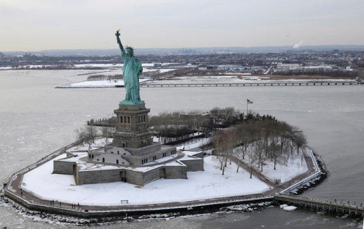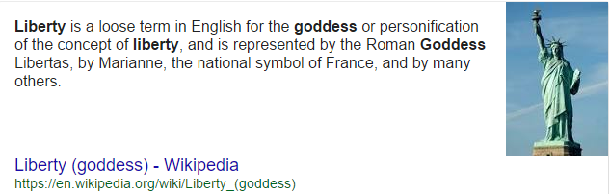

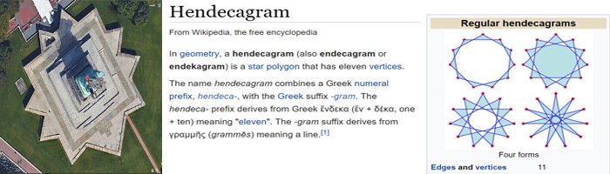



***Goddess of liberty standing on top of the qliphoth, connected to a transmutation circle.***

***Holding our eternal angelic light.***

**Mother Of Exiles**

The statue, Goddess of liberty is also known as the *mother of exiles*, the name given to her from the sonnet poem casted onto a plaque and mounted inside the pedestal’s lower level , written by Emma Lazarus in 1883. *We are the exiles,* the angels that are cast out from heaven. The statue, Goddess of Liberty is Satan masquerading as the *mother goddess*

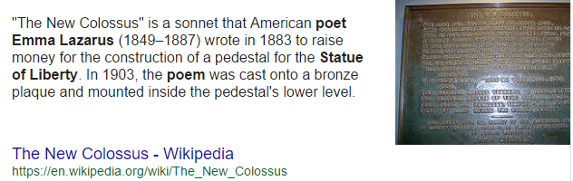

**The New Colossus** – Sonnet Poem

Not like the brazen giant of Greek fame,  
With conquering limbs astride from land to land;  
Here at our sea-washed, sunset gates shall stand  
A mighty woman with a torch, whose flame  
Is the **imprisoned lightning**, and her name  
**MOTHER OF EXILES**. From her beacon-hand  
Glows world-wide welcome; her mild eyes command  
The air-bridged harbor that twin cities frame.  
  
"Keep, ancient lands, your storied pomp!" cries she  
With silent lips. "Give me your tired, your poor,  
Your huddled masses yearning to breathe free,  
The wretched refuse of your teeming shore.  
Send these, the homeless, tempest-tost to me,  
I lift my lamp beside the golden door!"

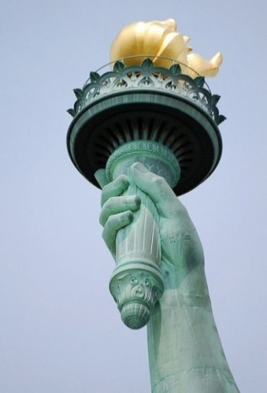

For the moment, let us refer to Satan as a she for goddess liberty. She is standing on top of a hendecagram which is an 11 pointed star. The hendecagram also represents the qliphoth which symbolises our human host body and is also known as **Lucifer’s Star**. She is holding a torch over her head which represents our angelic energy. She is using our light to illuminate her way as she keeps us angels in the dark beneath her.

**The Light Bearer**

Did you know that Satan is known as the light bearer?

Satan was called Lucifer in heaven before he led the rebellion that took place. In the Latin Vulgate translation Lucifer means light bearer in Latin. He received the name Satan after his fall.

[*Wikipedia*](https://en.wikipedia.org/wiki/Laws_of_thermodynamics)*, the free encyclopedia*

**Lucifer** is the [King James Version](https://en.wikipedia.org/wiki/King_James_Version) rendering of the [Hebrew](https://en.wikipedia.org/wiki/Hebrew_language) word הֵילֵל in [Isaiah](https://en.wikipedia.org/wiki/Book_of_Isaiah) ([Isaiah 14:12](https://www.biblegateway.com/passage/?search=Isaiah+14%3A12&version=KJV)). The [Vulgate](https://en.wikipedia.org/wiki/Vulgate) translation uses the [Latin](https://en.wikipedia.org/wiki/Latin) word *lucifer*, but with a lower-case initial, The Hebrew word, transliterated *Hêlêl* or *Heylel* (pron. as *HAY-lale*), occurs once in the [Hebrew Bible](https://en.wikipedia.org/wiki/Hebrew_Bible) and according to the KJV-based [Strong's Concordance](https://en.wikipedia.org/wiki/Strong%27s_Concordance) means **"shining one, light-bearer"**. The [Septuagint](https://en.wikipedia.org/wiki/Septuagint) renders הֵילֵל in [Greek](https://en.wikipedia.org/wiki/Greek_language) as ἑωσφόρος (*heōsphoros*), a name, literally **"bringer of dawn"**, for the morning star. The word *Lucifer* is taken from the [Latin](https://en.wikipedia.org/wiki/Latin) [Vulgate](https://en.wikipedia.org/wiki/Vulgate), which translates הֵילֵל as *lucifer*, meaning "**the morning star**, the [planet](https://en.wikipedia.org/wiki/Planet) [Venus](https://en.wikipedia.org/wiki/Venus)", or, as an adjective, **"light-bringing"**.

Why do you suppose Lucifer known as Satan is the light bearer?

Lucifer is the light bearer because he brought our light, our eternal angelic light, which he took down to earth by tempting, deceiving and trapping us angels in a snare, the qliphoth host body / system, the carnal state I refer to as the realm of the flesh. This whole world is his host body system that he created and trapped our angelic energy into.

***Image of Satan the light bearer masquerading as the female goddess.***

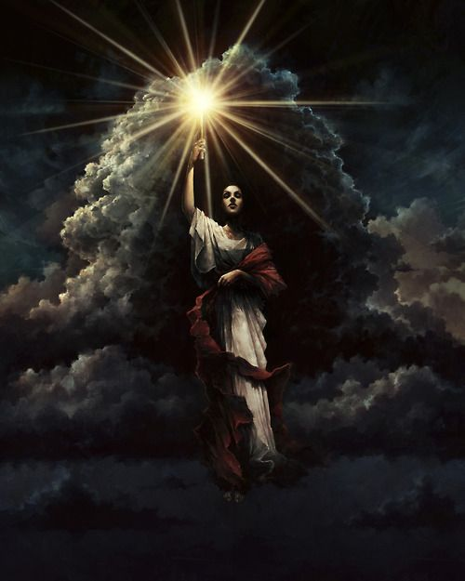

**Spark Of Life**

Before we begin on the topic of the spark of life, I need to explain that Satan created the female energy system that we’re in. The male and female energies are opposed to each other and every human body is at war within because the female energy is trying to take over. This is why the Lord God came in the form of the male energy, in the masculine sense to save us on the cross. The male energy comes from the Lord God.

It takes a male and female to create an embryo. It’s the male sperm which fertilizes the female egg. Recently scientist discovered that at the moment the female egg is fertilized, in proportion to the egg, a huge spark occurs. Scientists call it the spark of life. That is when a child is conceived and the life begins inside the egg. That spark of life is when we angels, enter into the newly created host body our qliphoth.

As it was just revealed in the study above, Satan masquerades as mother Goddess and the female energy rules his kingdom on earth. Satan has control over the host body through Cain, the first created. Cain had Satan’s genome in his DNA and it is through this line that Satan controls our host body. The male carries Satan’s gene in the sperm and through the act of sex, a female egg becomes fertilized creating the spark of life. Angels enter the Host body system in the womb and the qliphoth is created.

*Fertilization moment, the spark of life.*

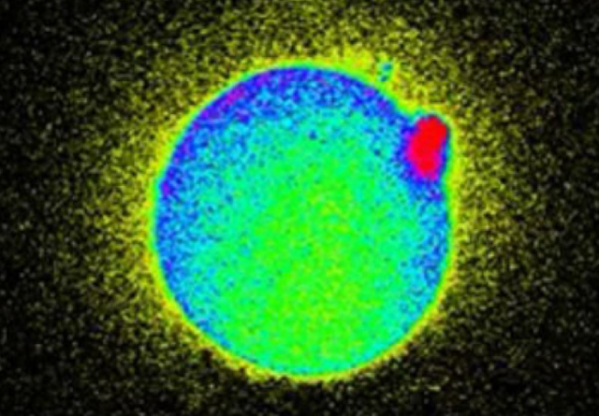 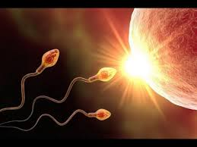

*Moment angels enter the realm of the flesh and become trapped in the host body, the qliphoth.*

*Sperm entering into a portal from heaven to the realm of the flesh, the matrix (the woman’s womb) Genesis 1:2*

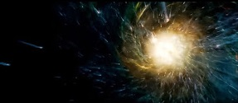

*End scene of the 2014 movie LUCY*

**Mitochondria The Powerhouse**

They are continuously stealing our breath of Life that was given to us from the Lord, our angelic light energy. In biological or scientific terms, this is done at the cellular level, within the **mitochondria**.

The Mitochondria is known as the powerhouse of every cell and the energy production of every cell in the human body.

The mitochondria produce’s all the energy for every cell, in every human being on the planet. It produces the breath for every cell called cellular respiration.

The surface that creates the energy for the mitochondria is the Cristae. Sounds like Christ don’t it?

To simplify this, Satan takes our breath from us at the cellular level, from the mitochondria. The Mitochondria has been appropriated, stolen, hijacked. The process in which they take our breath of life is constantly taking place because we are eternal angels trapped in these hosts’ bodies.

We are being used as an energy source for them like batteries and eventually as our host body gets older it becomes less efficient at producing energy for them and it eventually dies.

What takes place after death is profound. If you don’t get converted before you die your eternal angelic light energy becomes food for them *(the locust in the pit)* below, which will be covered later. Your light energy is constantly being transmuted into dark energy.

A quick biology lesson about the **Mitochondria** and the role it plays in our host body. Let us have an elementary look at how it works.

*The Mitochondria Is Where Satan Takes Our Breath Of Life From.*

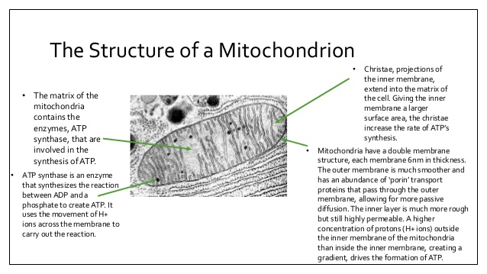

*Continuation of the mitochondria.*

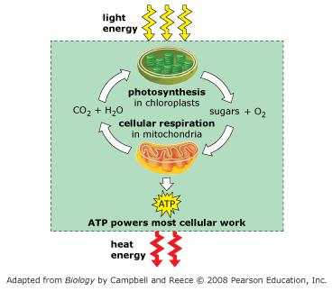

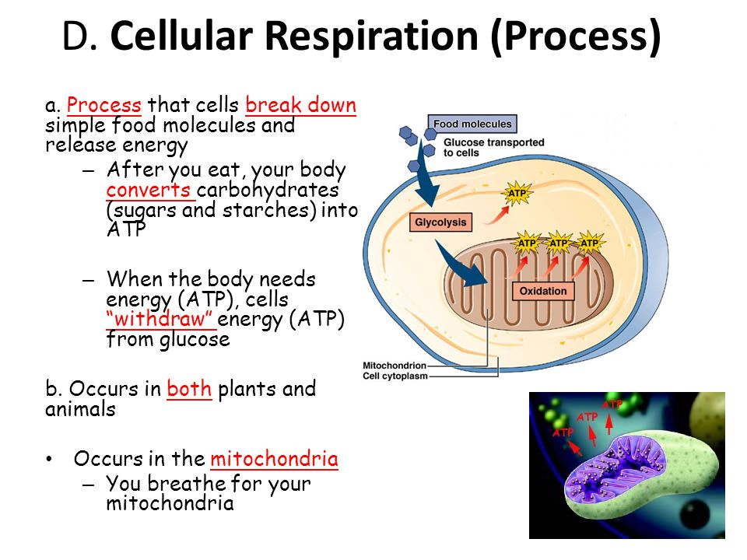

*Continuation of the mitochondria.*

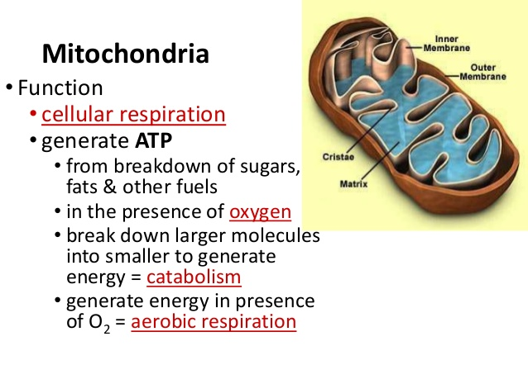

**Heart Mitochondria: Gates Of Life And Death**

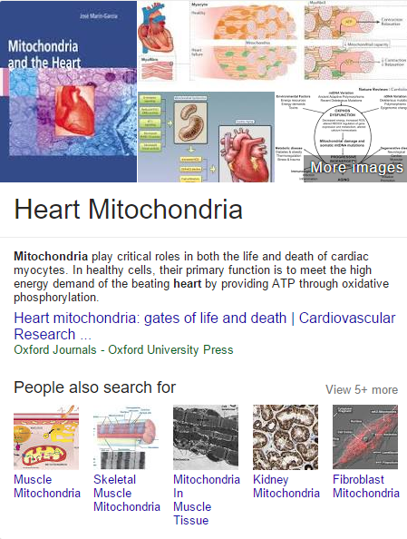

*<https://www.google.com/search?source=hp&ei=2SNFW4u8C4uJ0wKRlq-gCQ&q=heart+mitochondria&oq=heart+mitochondria&gs_l=psy-ab.3..0j0i22i30k1l9.1241.5561.0.5759.19.10.0.8.8.0.158.1230.0j10.10.0....0...1c.1.64.psy-ab..1.18.1305.0..35i39k1j0i131k1j0i67k1j0i10k1.0.E_nU-6Jupoc>*

*Continuation of Heart Mitochondria: Gates Of Life And Death*

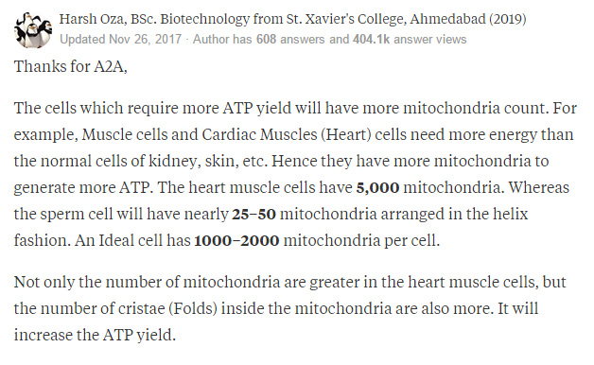

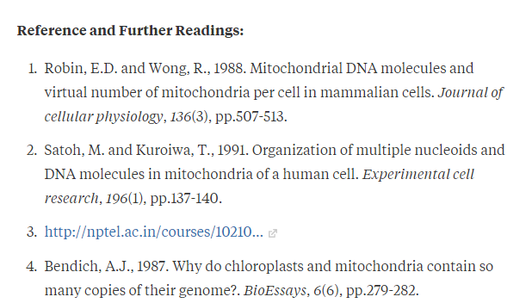

[*https://www.quora.com/Which-cells-have-the-most-mitochondria-in-them*](https://www.quora.com/Which-cells-have-the-most-mitochondria-in-them)

*When reading on the Woman Arrayed in Purple below, take note of the colors* ***Red*** *and* ***Blue*** *in the* ***HEART****.*

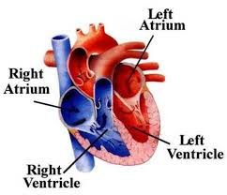

**The Woman Arrayed In Purple And Scarlet**

The Lord God has revealed the mystery of **the** **woman arrayed in purple and scarlet** that is written in **Revelation 17** in the bible. Many scholars have pondered this verse with various opinions but let’s dive in a little and examine this further.

The woman arrayed in purple and scarlet colour; she represents the female energy, our host body qliphoth. I will bring this all together proving out even more the revelation that we are angels

**Revelation 17:1-5** New King James Version*(NKJV)*

**1** Then one of the seven angels who had the seven bowls came and talked with me, saying to me, “Come, I will show you the judgment of the great harlot who sits on many waters,

**2** with whom the kings of the earth committed fornication, and the inhabitants of the earth were made drunk with the wine of her fornication.”

**3** So he carried me away in the Spirit into the wilderness. And I saw a woman sitting on a scarlet beast *which was* full of names of blasphemy, having seven heads and ten horns.

**4** The woman was arrayed in **purple*G4209***and **scarlet*G2847***, and adorned with gold and precious stones and pearls, having in her hand a golden cup full of abominations and the filthiness of her fornication.

**5** And on her forehead a name *was* written:

MYSTERY, BABYLON THE GREAT,  
THE MOTHER OF HARLOTS  
AND OF THE ABOMINATIONS  
OF THE EARTH.

*Bible definitions of Strong’s Greek word* ***purpleG4209***

*Πορφύρα, porphura, por-foo'-rah****G4209***

*Of Latin origin; the “purple” mussel, that is, (by implication) the* red blue *color itself, and finally, a garment dyed with it: - purple.*

**Total KJV occurrences: 5**

*Bible definitions of Strong’s Greek word* ***scarletG2847***

*Κόκκινος, kokkinos, kok'-kee-nos****G2847***

*From G2848 (from the kernel shape of the insect); crimson* colored*: - scarlet (colour, coloured).*

**Total KJV occurrences: 6**

Let’s put the words that have been discovered all together like a puzzle. The reasons why I highlighted the words the purple mussel***G4209*** and the garment dyed with it***G4209*** is because our **host body**, the qliphoth is as a purple garment ***G4209***, a covering like a shell of a mussel***G4209*** over us, that is red and blue which makes its purple color. *Proven out on following pages*

*Continuing with Revelations 17 for the woman arrayed in purple.*

Regarding the scripture, **4** The woman was arrayed in **purple*G4209***. When we combine the colors red and blue we get purple.

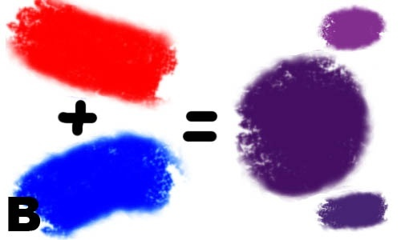 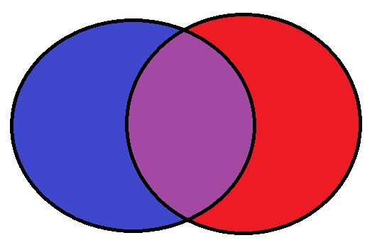

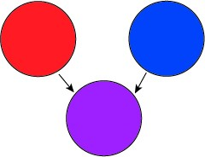

Using the scriptures definitions, In **Revelations 17** the woman was arrayed in purple***G4209***and scarlet***G2847***.

By now It should be coming together; this scripture is not only referring to the woman, of the female energy, but also referring to our host body, the qliphoth that is adorned purple from the**red** and **blue**colors. *(Proven out on page 19, 20, 21)*

The revelation that the Lord revealed is that we *(angels in host body)* are the woman arrayed in purple and scarlet and we are controlled by the female energy**.**

To prove this out further, let’s look at the Human body in biology. Notice how the scripture definition on the previous page for purple***G4209*** is *the* **red** and **blue** *color itself.* In biology our bodies are covered with Veins and Arteries. Our veins are blue and our arteries are red.

*Continuing with Revelations 17 for the woman arrayed in purple.*

In Science and biology we know that our veins are **blue** and our arteries are **red**. Stay with me just a little longer and this revelation will be made very obvious.

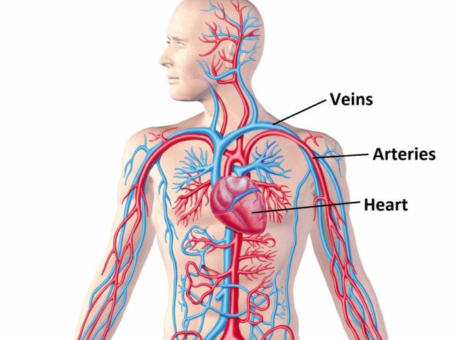

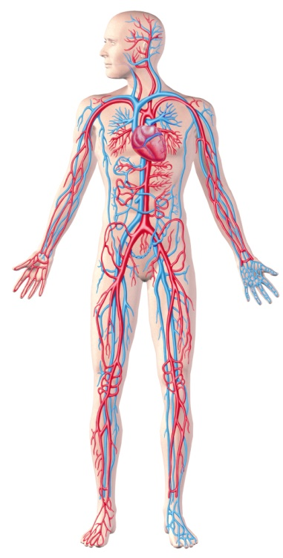

In Revelation 17, the woman arrayed in purple represents our human host body. When our veins and arteries are put together we become arrayed in the color purple. We wear this host body like a garment over us, that house’s our eternal angelic light.

**Male And Female Chromosomes**

Our human host body, the qliphoth is owned by Satan. He masquerades as the female goddess and his energy is female. So far there has been some mention that Satan is the female energy and that this energy is opposed to the male energy which is our father the Lord God.

Our human host bodies carry Satan’s energy, the female energy. We were all conceived in the Womb by the male and female chromosomes. The male chromosome is the XY and the female is the XX. The male chromosome carries the female energy in the sperm, also known as the serpent seed, which will be talked about later.

Why do you suppose our father, the Lord God was conceived from a virgin?

The Almighty God himself, the Holy Ghost impregnated the Virgin Mary so as to not have the male sperm *(the serpent seed)* enter the female egg thus preventing Satan’s seed *(the female energy)* from entering Jesus’s host body. This made Jesus host body sinless and perfect in all His ways. The male sperm carries Satan’s seed *(the female energy)* and it brings this energy into the host body.

I will explain how significant this is below.

**Female and Male Chromosome**

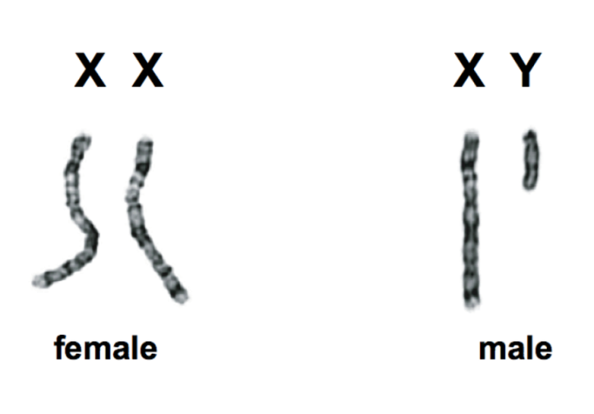

**The Birth of Jesus Christ from a Virgin**

**Luke 1:35** *(KJV)* And the angel answered and said unto her, **The Holy Ghost shall come upon thee**, and the power of the Highest shall overshadow thee: therefore also that holy thing which shall be born of thee shall be called the Son of God.

**Matthew 1:18** *(KJV)*  Now the birth of Jesus Christ was on this wise: When as his mother Mary was espoused to Joseph, before they came together, she was found with **child of the Holy Ghost**.

**Matthew 1:23** *(KJV)*  Behold, a **virgin** shall be with child, and shall bring forth a son, and they shall call his name **Emmanuel**, which being interpreted is, **God with us**.

**Isaiah 7:14** *(KJV)*  Therefore the Lord himself shall give you a sign; Behold, **a virgin shall conceive**, and bear a son, and shall call his name **Immanuel**.

**Female Energy**

We mentioned earlier that Satan masquerades as mother Goddess, the female energy. This is the energy he

exploited and unfolded to rule the world and our host bodies.

Everyone with a host body has male and female energy that wars with each other continuously for control. The manifestation of this war is the continuous sinful state we are in.

Our host body is inherently evil. The continuous war of the male and female energy in our host body creates more sin and acts as the fuel for the transmutation process of our eternal angelic light, turning it into darkness.

**Isaiah 30:1** *(KJV)* Woe to the rebellious children, saith the LORD, that take counsel, but not of me; and that cover with a covering, but not of my spirit, that they may add sin to sin:

Continuing on this topic, linguistically and semantically the word FEMALE was intentionally made to parallel the word MALE. The letters **FE** differentiate the word **FE-MALE** from the word **MALE**.

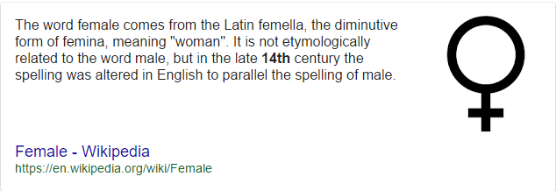

Let’s look at how this becomes relevant.

In linguistics and semantics the letters **FE** for **FE-male** describe and portray the woman. It is the woman; Eve that Satan had intercourse with and Eve then bore Cain ***(See Genesis 3:15 and 4)*.** It is through Cain that Satan took ownership over all human host bodies.

It is the **FE-male** energy which is carried through the male sperm to every host body.

It is the **FE-male** energy that Satan continuously utilizes to control our host body of everyone who has not given their life to Christ.

It is the **FE-male** goddess that Satan masquerades as *(think of the Goddess of Liberty)* and deceives everyone.

It is the **FE-male** energy that we war with in our human host body that keeps us in constant sin and eventually converts our eternal angelic energy to dark energy.

*Continuing with the Female Energy.*

In science the periodic table for elements for the letters **FE** is **IRON**.

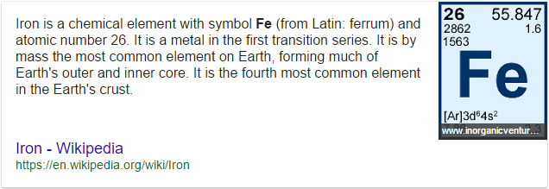

The letters **FE** also represent **IRON** in the periodic scale of elements. The **IRON** spoken of by **Daniel 2:43-44** is also the female energy. The **FE-male** energy is Satan’s energy; he created it to destroy us angels, Gods children.

Both **male** and **FE-male** energies are opposite each other. One is from Satan, *(****FE-male****)* and the other is from the Lord God *(****male****)*. The **male** energy is masculine, the Lord God is masculine and all his angels have masculine energy which is our eternal angelic **light**.

Given the information so far, the element **FE** for **IRON**, and the male and **FE-male** energies which are opposed to each other, also connect with one another and with the scriptures below.

**Daniel 2:43-44** *(KJV)* **-** **Iron** mixed with **Clay**

**43** And whereas thou sawest **iron** mixed with miry **clay**, they shall mingle themselves with the seed of men: but they shall not cleave one to another, even as iron is not mixed with **clay**.

**44** And in the days of these kings shall the God of heaven set up a kingdom, which shall never be destroyed: and the kingdom shall not be left to other people, *but* it shall break in pieces and consume all these kingdoms, and it shall stand for ever.

In this scripture **Daniel** is saying, the two energies or seed lines *(seed of the serpent and seed of the woman)* shall not cleave one to another, even as **iron** is not mixed with **clay**. Thisis in reference to the **male** and **FE-male** energies, also the enmity that the Lord God placed between the two seeds lines. ***(See Genesis 3:15)***

To bring this home for you, **Adam** was made of **clay**. The **male** energy **clay** came from our father, the Lord God. Adam was formed by the Lord God in paradise which is not on earth but in heaven. Afterwards Adam fell to earth with Eve and that is when they got their host bodies from Satan, the qliphoth which is a shell, peel or husk of serpent skin. From **the Targum Of Jonathan – Genesis** *“And the Lord God made to Adam and to his wife vestures of honour from the* ***skin of the serpent****, which he had cast from him, upon the skin of their flesh, instead of that adornment which had been cast away; and He clothed them.”* This is why it took the Lord God with the **male** **energy** to come into this flesh system as Jesus Christ to redeem us back.

**Genesis 2:7** *(KJV)*

**2** And the LORD God formed man *of* the **dustH6083** of the ground, and breathed into his nostrils the breath of life; and man became a living soul.

*Bible definitions of Strong’s Hebrews word* ***dustH6083***

*עָפָר, ‛âphâr,* *aw-faw'* ***H6083***

*From H6080;* *dust* *(as powdered or gray)*; *hence* ***clay***, *earth*, *mud: - ashes, dust, earth, ground, morter, powder, rubbish.* **Total KJV occurrences: 110**

**Our Kingdom Divided**

What is the consequence of having a male and female energy in our host body?

Since one energy is of the Lord God *(Male)* and the other of Satan *(Female)*. It causes a duality, a duplicitous nature that keeps us separated from our father. It divides us into two natures that are in constant war with one another. Even though it is an internal war that is ongoing, the struggle manifests in the most subtle and subdued ways, even during the calmest of moments in our lives. It affects our thoughts, our emotions and decisions in every way.

Keep in mind that Adam and Eve did not have Satan’s seed in their host bodies when they fell from paradise to earth. They were created by the Lord God, not birthed on earth as we were. Through Satan having sex with Eve then Eve birthing to Cain, the first debased strain was created, and subsequent pact with the watchman, the angels that had sex with the woman of men, continued the debasement of “man” *(originally angels)*. It was through these events that Satan’s seed eventually came into every host body that was born. Even though the host body qliphoth is evil and opposite of our father, for those who are saved and born again by the Holy Spirit, it is regarded as our temple because it houses the holiness which is of the Lord God.

**1 Corinthians 3:16** *(KJV)*  “Know ye not that **ye are the temple of God**, and that the **Spirit of God dwelleth in you**?”

Succinctly put: Through the co-mingling of the fallen angels with humans, a hybrid species was produced at the genetic level, and while the soul is angelic at birth, it too will eventually be converted to dark energy through the transmutation process that, as explained above, is persistently at work. This is exactly what is stated in the bible in **Genesis 6.**

**Genesis 6:2** *(KJV)*

**2** That the sons of God***H430*** saw the daughters of men that they *were* fair; and they took them wives of all which they chose.

*Bible definitions of Strong’s Hebrews word God* ***H430***

*אֱלֹהִים*,'ĕ*lôhı̂ym, el-o-heem'****H430***

*Plural of H433; gods in the ordinary sense; but specifically used (in the plural thus, especially with the article)* ***of the*** *supreme God; occasionally applied by way of deference to magistrates; and sometimes as a superlative: - angels, X exceeding, God (gods) (-dess, -ly), X (very) great, judges, X mighty.*

**Total KJV occurrences: 2601**

And in **Genesis 3:15** the bible says, “I will put enmity between the seed of the woman and the seed of the serpent”, because sexual intercourse happened between Satan and Eve, producing the hybrid species through Cain’s line.

**Genesis 3:15** *(KJV)*

**15** And I will put enmity between thee and the woman, and between thy seed and her seed; it shall bruise thy head, and thou shalt bruise his heel.

Here we obviously have two seeds that are in conflict with one another. The seed of the serpent takes over what was previously a united temple, so to speak. Through the co-mingling, the temple has become a kingdom divided and of a dual nature and as one gets stronger, the other dies. Hence we are the sheep that are dying and the devil is taking over. Our soul is the energy that is consumed.

*Continuing Our Kingdom Divided, We are the Lord God’s sheep.*

**John 10:1-5** *(KJV)*

**1** Verily, verily, I say unto you, He that entereth not by the door into the sheepfold, but climbeth up some other way, the same is a thief and a robber.

**2** But he that entereth in by the door is the shepherd of the **sheep**.

**3** To him the porter openeth; and the **sheep** hear his voice: and he calleth his own **sheep** by name, and leadeth them out.

**4** And when he putteth forth his own **sheep,** he goeth before them, and the **sheep** follow him: for they know his voice.

**5** And a stranger will they not follow, but will flee from him: for they know not the voice of strangers.

Jesus said “that every Kingdom divided against itself is brought to desolation.”

**Matthew 12:25** *(KJV)*

**25** And Jesus knew their thoughts, and said unto them, every kingdom divided against itself is brought to desolation; and every city or house divided against itself shall not stand:

Because Jesus statement is so clear, we can easily ascertain that the abomination that causes desolation is the alien seed otherwise the serpent seed that is growing within us, which is the female energy that is consuming the male energy. While we are trapped in the temple, one seed grows and another seed is being destroyed. That means that the evil seed is making desolate the temple of God which is our bodies and we have simply become a host body for the devil.

**Condition of our Kingdom Divided**

 

**Duality**

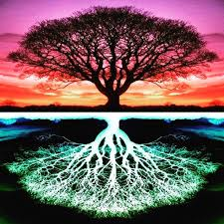 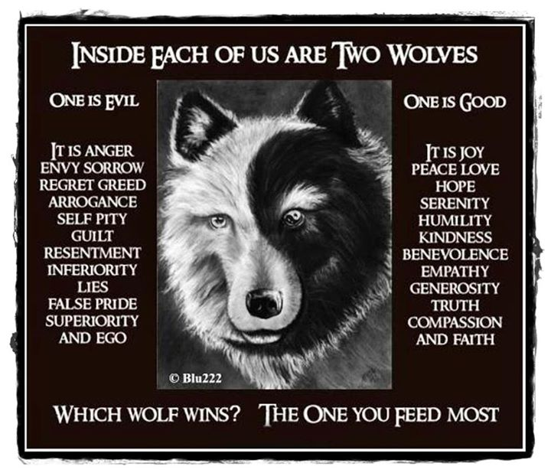

**The Antichrist Barack Obama**

It has been revealed to the Lord God’s saints, that the last president known as **Barak Hussein Obama** is the biblical **Antichrist**, who Satan will take over and completely possess his body.

At that time, Satan will manifest and Obama will come out of the shadows and rule for the time permitted by the Lord God. With the promise of peace, he will bring about death and destruction.

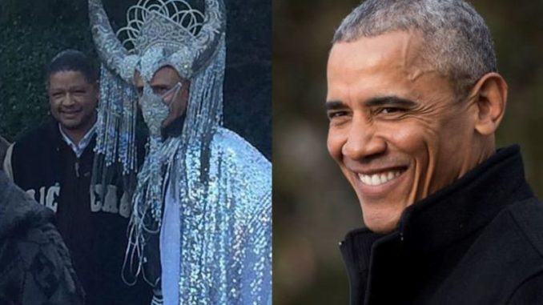

[*https://thetruthrevolution.net/disturbing-image-of-barack-obama-dressed-as-satan/*](https://thetruthrevolution.net/disturbing-image-of-barack-obama-dressed-as-satan/) *(****Partially quoted from this article.)***

“The photo, which provides a behind-the-scenes glimpse into the real world inhabited by Barack Obama, was originally uploaded on Instagram by Annemarie Hope, an artist who has been recognized for her work promoting Satanism and is known as a favorite of the international elite.

The photo appeared with the caption, “Class and Grace, You are my favorite“, and it soon went viral on Instagram. Skeptics questioning its authenticity, immediately claimed the image was photo shopped or fake, however after skeptics and pros used various techniques to determine whether the image was edited or tampered with, it shows to be authentic.

The revelation that Obama attends “Satanic parties” and dresses as Satan/Baphomet comes as no surprise to many observers of the former president. However some people are finding it hard to come to terms with the revelation.

It seems unlikely that Obama would dress up as Satan/Baphomet for a fancy dress competition or on Halloween. The fact that the person standing next to Obama is Artur Davis, an attorney and politician who served as a Democratic member of United States House of Representatives from 2003 to 2011, this image appears to also show Artur Davis dressed normally, suggests that this photo was not taken at a fancy dress party, but rather that Obama was participating in a Satanic ritual and paying his respects to his Lord Satan.”

**The Meaning Of 666 And The Antichrist**

**Revelations 13:18** *(KJV)*

**18** Here is wisdom. Let him that hath understanding count the number of the beast: for it is the number of a man; and his number ***is* Six hundred threescore *and* six**.***G5516***

*Bible definitions of Strong’s Greek word* ***is Six hundred threescore and six G5516***

*Χξς, chi xi stigma, khee xee stig'-m****G5516***

*The 22nd, 14th and an obsolete letter (G4742 as a* cross*) of the Greek alphabet (intermediate between the 5th and 6th), used as numbers; denoting respectively 600, 60 and 6;* ***666*** *as a numeral: -* ***six hundred threescore and six****.*

***Total KJV occurrences: 1***

Here is the mystery of 666 and our host body. All known life on earth is **Carbon** based. We angels have host bodies that also have DNA, chromosomes and **Carbon**.

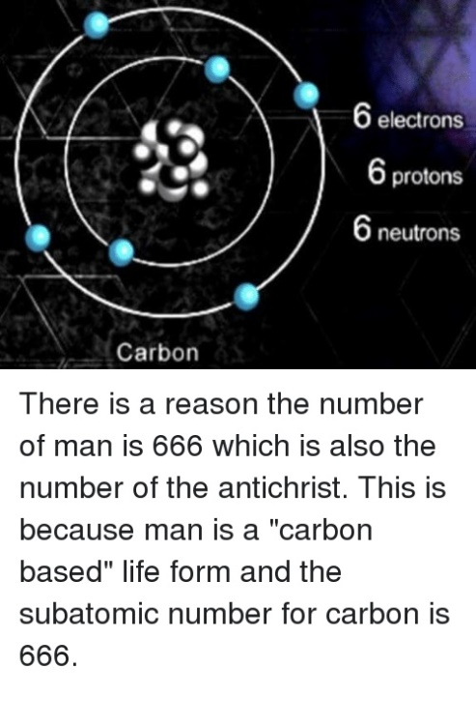

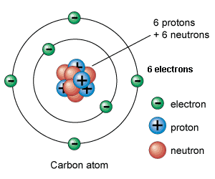

*Continuing on The Meaning Of 666 And The Antichrist*

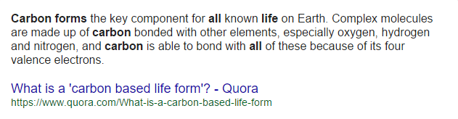

Satan went outside the Lords will and created the host body / system and the earth. This would mean that the realm of the flesh, DNA is Satan’s creation. As we know it, it is universal that all life on earth has a DNA code *(with minor exceptions)* and all life on earth is male and female *(energy)* with XY and XX chromosomes.

[**DNA, Genes and Chromosomes — University of Leicester**](https://www.google.com/url?sa=t&rct=j&q=&esrc=s&source=web&cd=1&cad=rja&uact=8&ved=0ahUKEwjRz87CrP_bAhWB_p8KHWIDANEQFggsMAA&url=https%3A%2F%2Fwww2.le.ac.uk%2Fprojects%2Fvgec%2Fhighereducation%2Ftopics%2Fdna-genes-chromosomes&usg=AOvVaw1B_87IeR9r6mBGTJ9ANFZg)

Codons. There *are* a two points to note about the genetic code: It is universal. **All life on Earth** uses the same code *(with a few minor exceptions)*. It *is* degenerate.

[*https://www2.le.ac.uk/projects/vgec/highereducation/topics/dna-genes-chromosomes*](https://www2.le.ac.uk/projects/vgec/highereducation/topics/dna-genes-chromosomes)

**Revelations 13:17**  And that no man might buy or sell, save he that had the mark, or the name of the beast, or the number of his name.

Going by the scripture **Revelation 13:18**, we get that number of his name by adding **6 + 6 + 6** = **18**, and it is referring to a male because we see the word **he**. The name **Barack Hussein Obama** has **18 characters** to the name and **he is a male**.

Jesus said to His disciples in **Luke 10:18** *(KJV)* And he said unto them, I beheld **Satan as lightning fall from heaven**.

In **Luke 10:18**, the Hebrew words that Jesus would have used for that time to the disciples would have been.

**Barak**, also transliterated as **Baraq**. In Hebrew **Baraq** means **LIGHTNING** *(Strong’s Hebrew word 1300)*

Even in the Greek, Barak means **LIGHTNING** for the name of an individual *(Strong’s Greek word 913)*

The only way a Jewish rabbi in that time, could say in Hebrew, SATAN as LIGHTNING is SATAN as **BARAK**

The Greek word for **FALL** in **Luke 10:18** only translate to a Hebrew word for transgression, so the words of Jesus in this verse Luke 10:18 for the word **FALL** is probably referring to some heavenly transgression that took place.

The use of **BAMAH** *(Strong’s Hebrew word 1116)* is used to refer to the **“Heights” of Heaven**.

The letters **O** or U in Hebrew are used as a conjunction primarily used to join concepts together. So to join the concept of lighting to Heaven, would be the letters **O** or the U in Hebrew.

The word **BAMAH** is primarily used to refer to a High place as well as the heights of the heavens or even the clouds.

So this Jesus prophecy of **Luke 10:18**, If spoken actually today by a Jewish rabbi, would go like this.

“I Beheld Satan **as Barak Obama**”

There are many others factors that prove Barack Obama is the biblical antichrist but for this purpose, I will leave that topic open for discussion.

**2 Creation Accounts**

Now that it has been revealed we are angels. Let’s focus a little on the creation account in heaven. What has been hidden from people is that there are two separate creation accounts in the bible. Both **Genesis 1** and **Genesis 2** that have been presented by religious institutions as though it is 1 creation account. However, in **Genesis 1**, when it reads God, it’s referring to Satan, and the Lord God’s angels. In **Genesis 2**, God is referring to the almighty Jehovah, the Lord God which makes them separate accounts. To reiterate, in **Genesis 1** the word God is Eloheem’ (Angels) and in **Genesis 2** God is Jehovah the Lord.

There is also other biblical evidence why we have two separate creations accounts but for this study, I will leave those out.

In **Genesis 1**, the Hebrew meaning for the word God ***H430*** *(Strong’s Hebrews word* ***H430****)* is

el-o-heem', angels, magistrates.

In **Genesis 2**, the Hebrew meaning for the words Lord God *(Strong’s Hebrews words* ***H3068*** *and* ***H430****)* is

yeh-ho-vaw'***H3068***, self-Existent or eternal; Jehovah, the Lord ***H3068***, God***H430***.

In **Genesis 1**, the word God means angels and magistrates. Satan and the angels created man in their image; in Genesis 1:26 **the whole world is the male and female energy system, the host body system, the realm of the flesh**. Here on earth everything dies. In Heaven there is no death and no male or female and we angels are eternal beings of light. These flesh bodies are the trap and our prison.

One of many question that could be asked is why did Satan trap us in this host body / system?

Satan hates us and he vowed to get back at the Lord God. Satan is stealing all of the Lord Gods children *(sheep)*, His angels’ eternal light essence, so Satan can then exalt himself above us and be like the most high.

**Isaiah 14:12-18** New King James Version *(NKJV)*

**The Fall of Lucifer**

**12** “How you are fallen from heaven,

O Lucifer, son of the morning!

How you are cut down to the ground,

You who weakened the nations!

**13** For you have said in your heart:

‘I will ascend into heaven,

I will exalt my throne above the stars of God;

I will also sit on the mount of the congregation

On the farthest sides of the north;

**14** I will ascend above the heights of the clouds,

I will be like the Most High.’

**15** Yet you shall be brought down to Sheol,

To the lowest depths of the Pit.

**16** “Those who see you will gaze at you,

And consider you, saying:

‘Is this the man who made the earth tremble,

Who shook kingdoms,

**17** Who made the world as a wilderness

And destroyed its cities,

Who did not open the **houseH1004** of his **prisonersH615**?’

**18** “All the kings of the nations,

All of them, sleep in glory,

Everyone in his own **houseH1004**

*Continuing on the 2 Creation Accounts*

*Bible definitions of Strong’s Hebrews words* ***houseH1004***

*בַּיִת,* *bayith,* *bah'-yith****H1004***

*Probably from H1129 abbreviated; a* house *(in the greatest variation of applications, especially family, etc.): - court, daughter,* ***door****, +* ***dungeon****, family, + forth of, X great as would contain, hangings. home[born], [winter]house (-hold), inside(-ward), palace, place, +* ***prison****, + steward, + tablet, temple, web, + within (-out).*

**Total KJV occurrences: 2053**

*Bible definitions of Strong’s Hebrews words* ***prisonersH615***

*אָסִיר, 'âsı̂yr,* *aw-sere'****H615***

*From H631;* ***bound***, that is, a ***captive****:* - *(those which are)* ***bound****,* ***prisoner****.*

**Total KJV occurrences: 14**

At this point another question arises. What is Satan going to do with our light energy, our soul once he traps it?

To answer that, I will need to briefly explain something first, without getting into too much detail. For Satan to have accomplished his goal, he first had to understand what he was dealing with in regard to our angelic energy, and then he had to figure out how to trap it, then how to convert it for his nefarious needs. So while he was cast out of heaven, he had a lot of time to figure out how to do this and so he created this human host body / system we are part of.

So first, what is our angelic energy?

**Messengers Of Flaming Fire**

The bible states that we are **angels of light**,messengersof **flaming fire**. Our essence is light spirit beings of energy from the Lord God.

***Hebrews 1:7*** *(KJV)*

**7** And of the **angelsG32** he saith, Who maketh his **angelsG32** **spiritsG4151**, and his ministers a **flameG5395** of **fireG4442**.

*Bible definitions of Strong’s Greek word* ***angelsG32***

*ἄγγελος, aggelos,* ang'-el-os***G32***

*From ἀγγέλλω aggellō (probably derived from G71; compare G34; to bring tidings)*; a *messenger*; *especially an* “**angel**”*; by implication a* pastor: *-* ***angel****, messenger.*

***Total KJV occurrences: 695***

*Bible definitions of Strong’s Greek word* ***spiritsG4151***

*πνεῦμα, pneuma,* pnyoo'-mah***G4151***

*From G4154;* a *current of air, that is,* ***breath* *(blast)*** *or a breeze*; *by analogy or figuratively* **a *spirit****, that is, (human) the* ***rational soul****, (by implication) vital principle*, *mental disposition*, *etc., or (superhuman)* ***an angel****, daemon, or (divine) God, Christ’s spirit, the Holy spirit: - ghost, life,* ***spirit*** *(-ual, -ually), mind. Compare G5590.*

***Total KJV occurrences: 385***

*Continuance of Messengers Of Flaming Fire*

*Bible definitions of Strong’s Greek word* ***flameG5395***

*Φλόξ phlox,* *flox****G5395***

*From a primary φλέγω phlegō (to “****flash****” or “flame”);* **a *blaze***: *-* ***flame (-ing****).*

**Total KJV occurrences: 7**

*Bible definitions of Strong’s Greek word* ***fireG4442***

*πῦρ, pur, poor****G4442***

*A primary word; “****fire****” (literally or figuratively, specifically* ***lightning****): -* ***fiery****, fire.*

**Total KJV occurrences: 74**

To reiterate this point a little differently. For those angels who do not become **CONVERTED** in Christ, through the Holy Spirit. When their host body *(shell)* dies on earth, their eternal angel energy called the soul becomes food for the locusts below and they get a Locust for a new host body. Satan is breeding us angels for food for them below and building an army of Locust to worship him and to war against our Father the Lord God.

All the locusts below are host bodies shells housing the energy of our fallen angel brothers that didn’t make it back. Their eternal energy that was once light is now dark and they are completely ruled by Satan’s FE-male energy. This time, within their new host bodies

**Converting Angels To Locusts**

So we know, angels are a form of energy, light beings from the Lord God. The understanding in the laws of physics in Thermodynamics is that energy can neither be destroyed nor created but it can be converted *(changed from one form of energy to another)*.

*Laws Of Thermodynamics - Wikipedia*

***https://en.wikipedia.org/wiki/Laws_of_thermodynamics***

*This states that energy can be neither created nor destroyed. However, energy can change forms, and energy can flow from one place to another. A particular consequence of the law of conservation of energy is that the total energy of an isolated system does not change.*

*A visual interpretation of converting angels to locusts.*

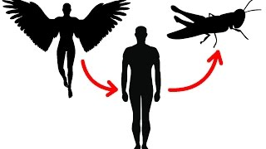

Our angelic light energy soul transmutated into dark energy for the Locust host body below.

*Continuance of Converting Angels To Locusts.*

In scripture, **Revelation 9** describes what the locusts are like.

**Revelation 9:7-10** *(KJV)*

**7** And the shapes of the locusts *were* like unto horses prepared unto battle; and on their heads *were* as it were crowns like gold, and their faces *were* as the faces of men.

**8** Andthey had hair as the hair of women, and their teeth were as *the teeth* of lions.

**9** And they had breastplates, as it were breastplates of iron; and the sound of their wings *was* as the sound of chariots of many horses running to battle.

**10** And they had tails like unto scorpions, and there were stings in their tails: and their power *was* to hurt men five months.

The Vatican has a plaque called the list of popes, on their wall. The plaque has the list of people, who have served as popes from the beginning of the Catholic Church to date and that have passed away.

The Lord God has revealed that when you turn the plaque for the list of Popes upside down, the plaque reveals and represent what the locust from the pit will look like.

Below are the images to prove man turns to locust in the pit, just as the bible says.

*List Of Popes – Vatican*

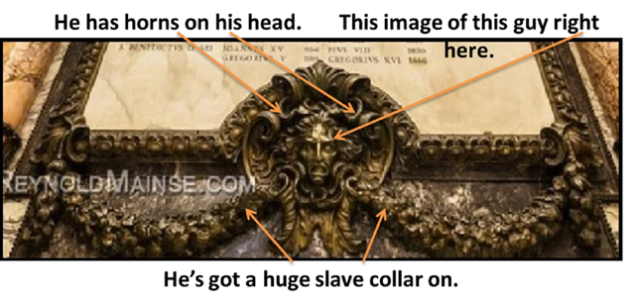

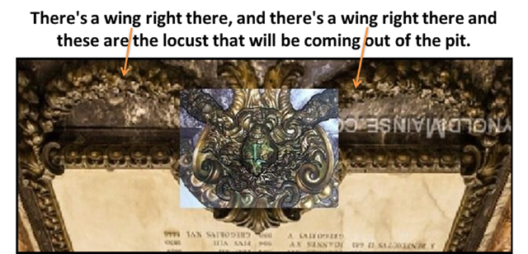

*Continuance of Converting Angels To Locusts.*

This represents the consequence of sin, unrepentance and not being converted through the Holy Spirit.

List Of Popes – Vatican

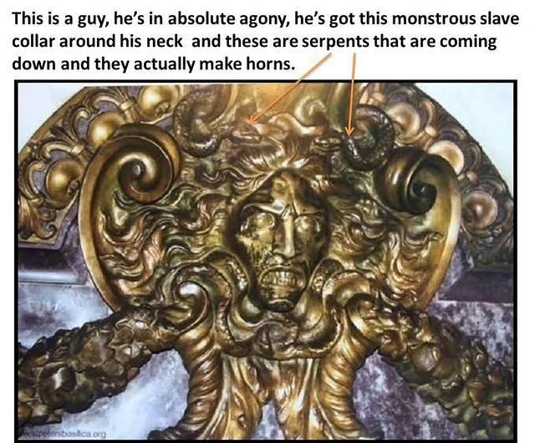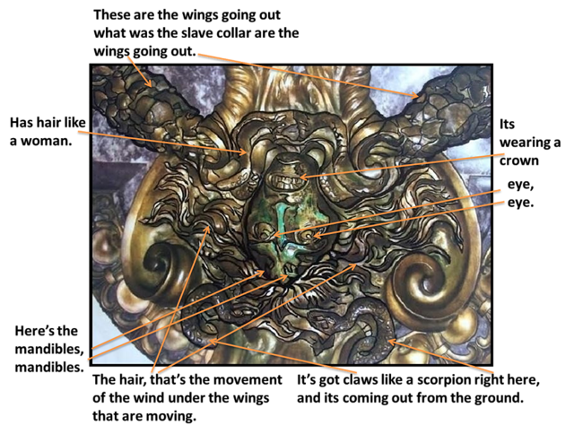

Some of you will ask the question, how many angels will make it back to heaven?

Some Christians strongly believe as do I, that 1 or even 2 of every thousand people *(angels)* will be saved by being **converted through the Holy Ghost**, by the washing of regeneration and renewing of the Holy Ghost.

For example, if we use the ratio of 1 of every 1000 people would be saved and by estimating that we are 7 billion people *(angels)* in the world today. For arguments sake, let’s add another 7 billion for those who have passed away since the beginning. This would bring the total number of angels that fell from the beginning till today to 14 billion. The calculation would be 14,000,000,000 / 1000 *(14 billion divided by 1000)* comes to 14 million people *(angels)* that will come back to heaven.

This means that only 14 million angels will make it back home, that truly have the love of the Lord in them. Those angels who make it back, they do so only because **the Lord God loved us first**.

**Matthew 7:14** *(KJV), (spoken words by Jesus in Red)*

**14**Because strait is the gate, and narrow is the way, which leadeth unto life, and **fewG3641**

there be that find it.

*Bible definitions of Strong’s Greek word* **fewG3641**

*ὀλίγος, oligos,* ol-ee'-gos***G3641***

*Of uncertain affinity;* ***puny*** *(in extent, degree, number, duration or value); especially neuter (adverbially)* somewhat: *- + almost, brief [-ly], few, (a)* ***little****, + long, a season, short,* ***small****, a while.*

**Total KJV occurrences: 43**

*Continuance of Converting Angels To Locusts.*

Using birth rates, life expectancy, census data and tax records throughout history, experts at the Population Reference Bureau were able to calculate the number of people who ever lived.

The World Population History

Estimated Figure Of All Who Ever Lived.

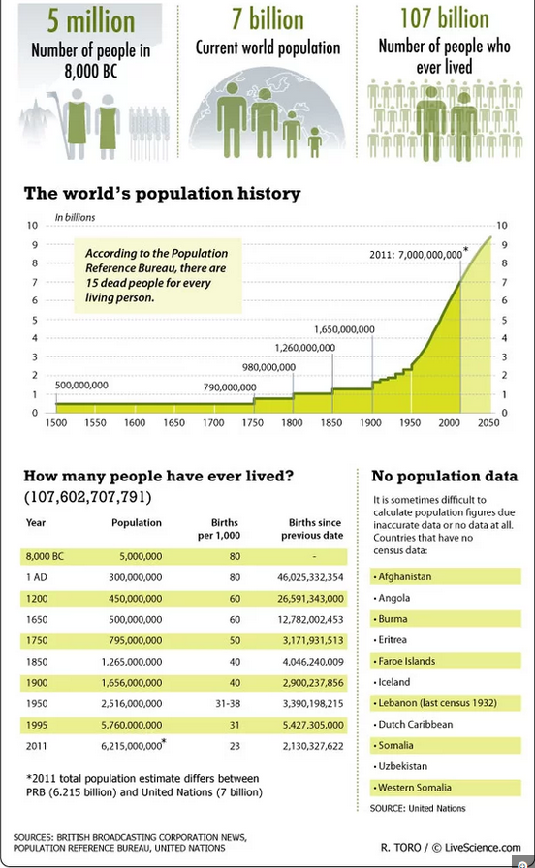

[*https://www.livescience.com/18336-human-population-dead-living-infographic.html*](https://www.livescience.com/18336-human-population-dead-living-infographic.html)

*Continuance of Converting Angels To Locusts.*

This is why Satan mocks us with dead sheep by the winking of the eye and sticking out the tongue, claiming we are dead and that, we angels are almost extinct.

Here is an example of that in the images below.



**Isaiah 52:5** *(KJV)* "And now what do I have here?" declares the LORD. "For my people have been taken away for nothing, and those who rule them mock," declares the LORD. "And all day long my name is constantly blasphemed.

**Isaiah 57:4** *(KJV)* Against whom do ye sport yourselves? against whom make ye a wide mouth, *and* draw out the tongue? *are* ye not children of transgression, a seed of falsehood,

**Psalms 35:19** *(KJV)* Let not them that are mine enemies wrongfully rejoice over me: *neither* let them wink with the eye that hate me without a cause.

**The Vatican Is The Altar Of Saint Peter That Is A Giant Dead Sheep**.

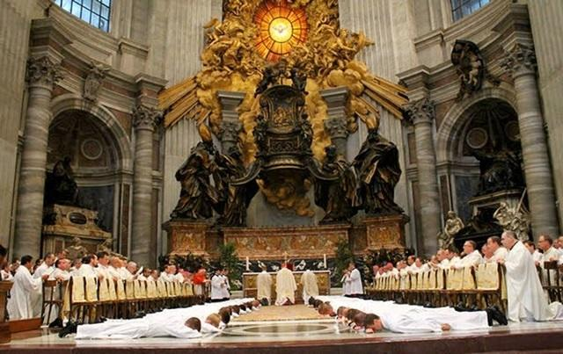 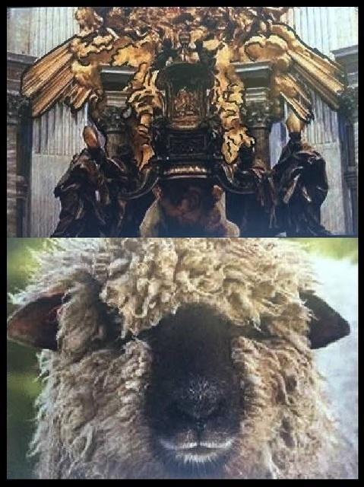

*Commentary made by Richard:*

“**IN A NUTSHELL**”

“We are all angels (immortal, invisible spirit beings), birthed into mortal, visible, fleshly bodies. God's angels (immortal spirit beings) are sucked into a Satanic spiritual vortex (i.e. sucked into the mouth of the serpent) under Satan's power and evil influence; and then birthed (changed) via the spiritual vortex (through the vagina). Thus, in our PERFECTION, we are torn from the INVISIBLE spirit realm (because of Lucifer), and birthed into IMPERFECTION in the VISIBLE, physical realm, as (fallen children of the Most High),,, AKA,,, HUMAN BEINGS... born into a mortal (husk or shell qliphoth) (the flesh), born in bondage, born IN SIN AND A STATE OF DUALITY, and cut off from the Creator Being, the Most High God, YHWH... and we are now under the curse of (both physical and spiritual) DEATH.

Because of the LIES and the TEMPTATION of the serpent (Lucifer the devil) and the subsequent fall from grace (of Eve, and then of Adam in the garden of Eden as a representation of ALL of us as angels in heaven); we have thus inherited the 'spiritual consequences' of that fall from grace... we have ALL inherited the stain of SIN and we have ALL incurred the (Satanic) CURSE OF DEATH; hence severing our divine spiritual link with the Most High God (YWHW) and losing the pure, angelic, pristine, sinless perfection and the IMMORTALITY that we once had).

In this wretched, fallen state: If we human beings still choose to rebel against the Most High God YHWH; and we reject His beloved Son Yahushua (Christ Jesus) as our blessed Redeemer and Saviour; (thus wilfully refusing to acknowledge what Christ Jesus did for us on the cross, as the Father's sacrificial lamb, shedding His most precious blood to take away our SINS, to destroy the power of the devil and remove the curse of DEATH that is upon us all), then those who reject Him CANNOT PARTAKE in the ALMIGHTY POWER of HIS RE-SURRECTION!! Since we are members of the IN-surrection that occurred in heaven.

If we die to this world, and we die with Yahushua (Christ Jesus) in our lives, then the redeeming power of His blood will cover us from God's wrath. If we trust in Him; believe in Him, and simply confess ourselves sinners worthy of death and deserving of our punishment, then we can receive the promise... ((We are Born again (turning the world upside/down))) AND THEN WE ARE BIRTHED BACK INTO OUR SPIRITUAL STATE IN WHICH WE ARE ABLE TO SEE AND PERCEIVE THE KINGDOM OF HEAVEN AND ARE GIVEN BACK THE LORD GOD'S HOLY SPIRIT AS A DOWN PAYMENT ON OUR ADOPTION BACK INTO ETERNAL LIFE.

However, if we die without Yahushua (Christ Jesus) in our lives, wallowing in our rebellion against God YHWH, and steeped in our SINS... we remain under the curse of death and Satan the devil remains in complete control of our (immortal) spiritual energy. Our physical body returns to the dust; and our spiritual energy / our angelic life force is transmuted (changed) and quite literally becomes 'DEMON FOOD'... being sent down into 'the bottomless pit' where we are satanically transformed into LOCUSTS. ((ALL OF WHICH END UP IN ETERNAL FIRE))”

**Conclusion**

For the moment, let’s set aside any stereotype there might be about religion and learn more about our condition. The truth is we are eternal spiritual beings who fell from heaven. Our sentence for the insurrection that we were a part of in heaven is death. So we are in a death sentence, born into death on a fallen plain which is the earth, with our minds in bondage in a prison of flesh. We are in a dimension of the flesh. The dimension of the flesh belongs to Satan who is the serpent.

The craziest thing of all is that it’s the grandest illusion ever created! Our whole existence here is a lie, that’s why in the bible it says that all those who love and live a lie are going to the pit. That is because they love the things of this world. Your existence here is a false reality, an illusion and most people don’t even know the truth. ***(See Revelation 21:8 and Revelation 22:15)***

People are blind to Satan’s machinations and they simply can’t see the illusion that they are in.

Here is the paradox that will fly in the face of what most people have believed their entire lives. What you thought was life from the moment you were born was actually death. You were actually born into death. You’re not even alive until you are born again in Christ. Once you are born again through the Holy Spirit then you are alive. **Ephesians 5:11-14** *(KJV)* Wherefore He saith, Awake thou that sleepest, and arise from the dead, and Christ shall give the Light.

Satan trapped all of us angels, the Lords sheep, so to convert our eternal angelic light energy, our souls to dark energy. So as to be food for his new race of beings, the locusts that at any moment will be coming out of the pit.

We are trapped in the flesh and the only way to get out of the flesh is to be born of the Holy Spirit. We have to be born again to become the temple of the Lord God. You see, until your born again you have a different spirit leading you. Your body and your soul are under condemnation.

Definition of condemnation: the action of condemning someone to a punishment; sentencing.

You see, Jesus came into this Matrix system of the flesh *(the World)* via a vehicle who was the virgin Mary. He was a Holy seed, an incorruptible seed that came into the system to buy back his children that are trapped in the flesh and being led by Satan’s Female energy *(also Sin)* which is in condemnation. Every Human being in the flesh system is under this energy that’s condemned.

When Jesus *(Holy Spirit)* comes into you, He turns you upside down and you get repolarized just like energy that flips over. Then when you die *(flesh host body)* your energy can’t go where it was heading *(downward)*, instead it goes the opposite direction *(upward)* because now you have been repolarized.

Satan rules all of us and this whole world. The people *(Elite)* he has given authority to govern us are doing his bidding. These elite families greatly influence or control most of the world governments and they are planning to destroy everything to begin their New World Order *(NWO)*. They know the truth about the Lord God, Christianity and the salvation through Jesus Christ. These elites worship Lucifer and they know that Jesus is coming to get His children out of harm’s way.

**Eyes to See and Ears to Hear Scripture**

**Matthew 13:10-15** *(KJV)*, (*spoken words by Jesus in Red*)

**10**And the disciples came, and said unto him, Why speakest thou unto them in parables?

**11**He answered and said unto them, Because it is given unto you to know the **mysteries of the kingdom of heaven**, but to them it is not given.

**12**For whosoever hath, to him shall be given, and he shall have more abundance: but whosoever hath not, from him shall be taken away even that he hath.

**13**Therefore speak I to them in parables: **because they seeing see not; and hearing they hear not, neither do they understand**.

**14**And in them is fulfilled the prophecy of Esaias, which saith,

**By hearing ye shall hear, and shall not understand; and seeing ye shall see, and shall not perceive:**

**15**For this people's heart is waxed gross, and their ears are dull of hearing, and their eyes they have closed; lest at any time they should see with their eyes and hear with their ears, and should understand with their heart, and should be **convertedG1994, and I should heal them**.

**16**But blessed are your eyes, for they see: and your ears, for they hear.

**17**For verily I say unto you, That many prophets and righteous men have desired to see those things which ye see, and have not seen them; and to hear those things which ye hear, and have not heard them.

*Bible definitions of Strong’s Greek word* ***convertedG1994***

*ἐπιστρέφω, epistrephō, ep-ee-stref'-o****G1994***

*From G1909 and G4762; to* ***revert*** *(literally, figuratively or morally): - come (go) again, convert,* ***(re-) turn*** *(about, again).*

**Total KJV occurrences: 39**

The Lord Gods intention for us has been to be part of His divine administration, the morning star administration.

**Revelations 2:28** *(KJV)* And I will give him the morning star.

The Lord wants us to do His will, to serve Him only, to be part of the unfolding of His creations, and give the good news to others. **Jeremiah 29:11** *(KJV)* For I know the thoughts that I think toward you, saith the LORD, thoughts of peace, and not of evil, to give you an expected end.

This is who the Lord God is; He creates, brings back into Himself and recreates life freely and abundantly.

**Hebrews 12:29** *(KJV)* For Our God is a consuming fire.

**We Are A Holy Temple For God To Occupy**.

**1 Peter 2: 4-10** King James 2000*(KJB2000)*

**4** To whom coming, as unto a **living stone**, rejected indeed of men, but **chosen of God, and precious**,

**5** You also, as **living stones**, are **built up** into a **spiritual house**, a **holy priesthood**, to offer up spiritual sacrifices, acceptable to God by Jesus Christ.

**6** Therefore also it is contained in the scripture, Behold, I lay in Zion a **chief cornerstone**, elect, precious: and he that believes on him shall not be confounded.

**7** Unto you therefore who believe he is precious: but unto them who are disobedient, the stone which the builders rejected, the same is made the head of the corner,

**8** And, A stone of stumbling, and a rock of offense, even to them who stumble at the word, being disobedient: to which also they were appointed.

**9** But you are a **chosen generation, a royal priesthood, a holy nation, a people for his own**; that you should show forth the praises of him who has **called you** **out of darkness into his marvelous light**:

**10** Who in time past were not a people, but are now the people of God: who had not obtained mercy, **but now have obtained mercy**.

Explanation of the scripture **1 Peter 2: 4-10**

* In this scripture, the **cornerstone** that is referenced is the **Lord Jesus Christ**.
* **Zion** is the Lord God’s chosen people, His saints. The ones who are saved and going back home to heaven, to live with the Lord God for ETERNITY.
* For those who don’t know or have a relationship with Jesus**. He** becomes a **stone of stumbling** and a **rock of offence** to them. He is the **snare** (offense) that turns them **upside down**.

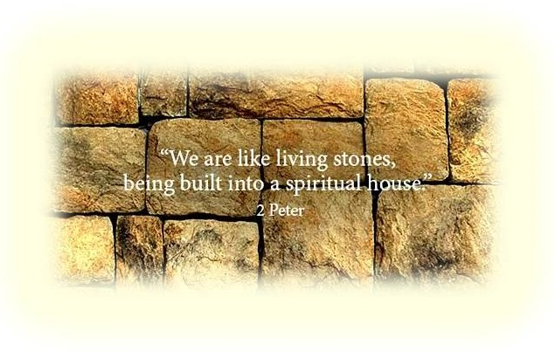

**Awaken Scripture**

**Ephesians 5:6-14** King James 2000 *(KJB2000)*

**6** Let no one deceive you with empty words, for because of these things the wrath of God comes upon the sons of disobedience.

**7** Therefore do not be partakers with them;

**8** for you were formerly darkness, but now you are Light in the Lord; walk as children of Light

**9** (for the fruit of the Light *consists* in all goodness and righteousness and truth),

**10** trying to learn what is pleasing to the Lord.

**11** Do not participate in the unfruitful deeds of darkness, but instead even expose them;

**12** for it is disgraceful even to speak of the things which are done by them in secret.

**13** But all things become visible when they are exposed by the light, for everything that becomes visible is light.

**14** Therefore he says,

**Awake you that sleep,**

**and arise from the dead,**

**and Christ shall give you light.**

**________________________________________**

**Inspiration Scripture**

[**Isaiah 40:31**](https://www.biblegateway.com/passage/?version=KJV&search=Isaiah%2040:31) ([*KJV*](https://www.biblegateway.com/versions/index.php?action=getVersionInfo&vid=9))

**31** But they that wait upon the Lord shall renew their strength; they shall mount up with wings as eagles; they shall run, and not be weary; and they shall walk, and not faint.

**Isaiah 43:1** (*KJV*)

**1** But now thus saith the Lord that created thee, O Jacob, and he that formed thee, O Israel, Fear not: for I have redeemed thee, I have called thee by thy name; thou art mine.

In **Isaiah 43**, Jacob and Israel that the Lord is speaking too are the angels that have been saved, converted.

May the Lord God bless you on your journey for the truth.

**REFERENCES**

**Jonathan Kleck:** *Prophet of the Lord God and the Angel of the church of Philadelphia*

*Websites: (*[*www.jonathankleck.com*](http://www.jonathankleck.com)*), (*[*www.keystothekingdomofheaven.com*](http://www.keystothekingdomofheaven.com)*), (*[*www.thisisitbe4thefire.com*](http://www.thisisitbe4thefire.com/)*),*

*Youtube: ([theJonathankleck](https://www.youtube.com/user/TheJonathankleck)), (*[*Be4TheFire*](https://www.youtube.com/channel/UC4JikLbC9WI9bQHEliJcceQ)*), ([secretmysterybusted](https://www.youtube.com/channel/UCbH9gBK0mLurt4e77j_7Phw))*

*Show Notes - Images: (*[*http://www.show-notes.info/thisisit4321/gallery3/index.php/*](http://www.show-notes.info/thisisit4321/gallery3/index.php/)*)*

**E-Sword bible:**

*Free download: (*[*www.e-sword.net/*](http://www.e-sword.net/)*)*

**Wikipedia:**

*Website: (*[*https://en.wikipedia.org/wiki/Wikipedia*](https://en.wikipedia.org/wiki/Wikipedia)*)*

**Barak Obama:**

*Article: (*[*https://thetruthrevolution.net/disturbing-image-of-barack-obama-dressed-as-satan*](https://thetruthrevolution.net/disturbing-image-of-barack-obama-dressed-as-satan)*)*

**Population Ref Bureau:**

*Website: (*[*www.livescience.com/18336-human-population-dead-living- infographic.html*](https://www.livescience.com/18336-human-population-dead-living-)*)*

*Other information referenced from (King James Bible) and Various Sources Not Listed*

***This is an image portraying the Locusts that will be coming out of the Pit.***

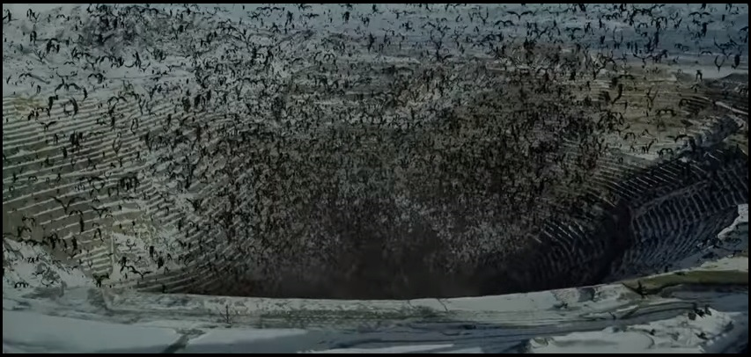

***Revelation 9***